**FIGURES**

Figure 1A, B, C. White Attitudes on Race and Education (1972-1996)

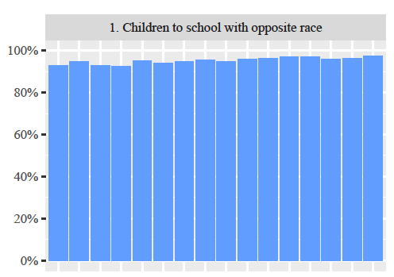

“Would you yourself have any objection to sending your children to a school where a few of the children are the opposite race [Negroes/Blacks/African-Americans]?”

Note: Total “RACFEW” responses over time: (N=18,821).

“No” responses over time: (*n*=17,903; 95.1%).

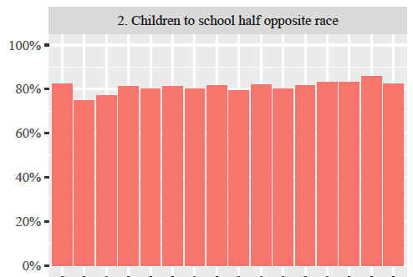

“Would you yourself have any objection to sending your children to a school where half of the children are [Negroes/Blacks/African- Americans]?”

Note: Total “RACHAF” responses over time: (N=17,507).

“No” responses over time (*n*=14,177; 81.0%).

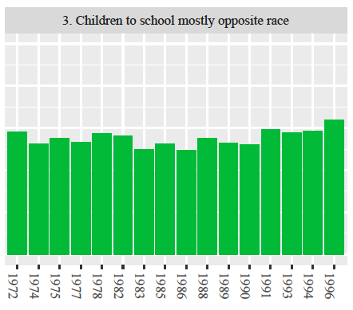

“Would you yourself have any objection to sending your children to a school where most of the children are [Negroes/Blacks/African- Americans]?”

Note: Total “RACMOST” responses over time: (N=13,754).

“No” responses over time (*n*=7576; 55.1%).

Figure 2A, B, C, D, E. White Attitudes on Race and Employment (1977-2016)

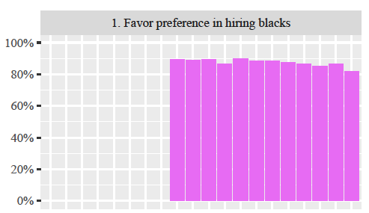

“Some people say that because of past discrimination, blacks should be given preference in hiring and promotion. Others say that such preference in hiring and promotion of blacks is wrong because it discriminates against whites. What about your opinion -- are you for or against preferential hiring and promotion of blacks?”

Note: Total “AFFRMACT” responses over time: (N=13,580).

“Against” responses over time: (*n*= 11,863; 87.4%).

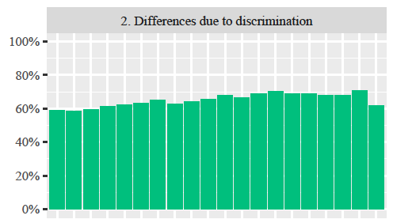

“On the average (Negroes/Blacks/African-Americans) have worse jobs, income, and housing than white people. Do you think these differences are mainly due to discrimination?”

Note: Total “RACDIF1” responses over time (N=22,177).

“No” responses over time (*n*=14,391; 64.9%).

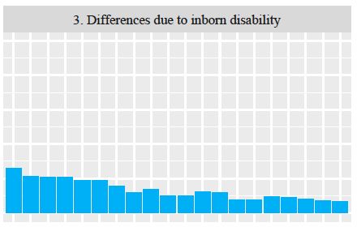

“On the average (Negroes/Blacks/African-Americans) have worse jobs, income, and housing than white people. Do you think these differences are because most (Negroes/Blacks/African-Americans) have less in-born ability to learn?”

Note: Total “RACDIF2” responses over time (N=22,470).

“Yes” responses over time (*n*=2.970; 13.2%).

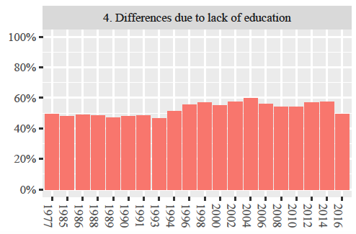

“On the average (Negroes/Blacks/African-Americans) have worse jobs, income, and housing than white people. Do you think these differences are because most (Negroes/Blacks/African-Americans) don't have the chance for education that it takes to rise out of poverty?”

Note: Total “RACDIF3” responses over time (N=22493).

“No” responses (*n*=11,769; 52.4%).

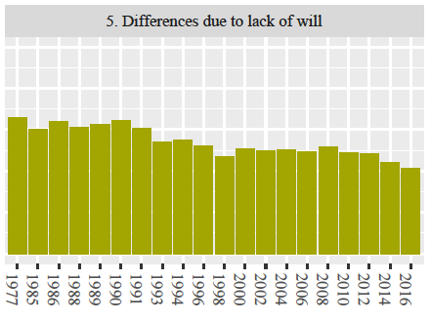

“On the average (Negroes/Blacks/African-Americans) have worse jobs, income, and housing than white people. Do you think these differences are because most (Negroes/Blacks/African-Americans) just don't have the motivation or will power to pull themselves up out of poverty?”

Note: Total “RACDIF4” responses (N=21,919).

“Yes” responses (*n*=11.801; 53.8%).

Figure 3A, B, C. White Attitudes on Race and Housing (1972-2016)

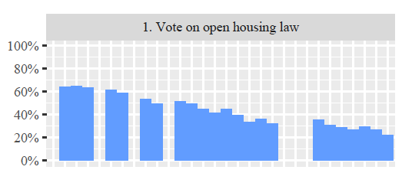

“Suppose there is a community-wide vote on the general housing issue. There are two possible laws to vote on: A: One law says that a homeowner can decide for himself whom to sell his house to, even if he prefers not to sell to (Negroes/Blacks/African-Americans). B: The second law says that a homeowner cannot refuse to sell to someone because of their race or color. Which law would you vote for?”

Note: Total population for variable “RACOPEN” (N=26,264).

“A” (the owner has the right to discriminate) responses (*n*=11,516; 43.8%).

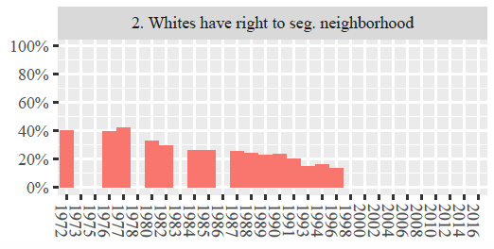

“Here are some opinions other people have expressed in connection with (Negro/Black)-white relations. Which statement on the card comes closest to how you, yourself, feel? The first one is: White people have a right to keep (Negroes/Blacks/African-Americans) out of their neighborhoods if they want to, and (Negroes/Blacks/African-Americans) should respect that right.”

Note: Total population for variable “RACSEG” (N=16,588).

“Agree Slightly” and “Agree Strongly” responses (*n*=4,571; 27.5%).

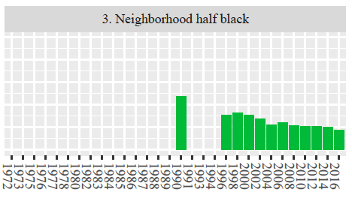

“Now I'm going to ask you about different types of contact with various groups of people. In each situation would you please tell me whether you would be very much in favor of it happening, somewhat in favor, neither in favor nor opposed to it happening, somewhat opposed, or very much opposed to it happening?  Living in a neighborhood where half of your neighbors were blacks?”

Note: Total population for variable “LIVBLK” (N=13,639).

“Oppose” and “Strongly Oppose” responses (*n*=547; 5.8%).

# Figure 4A, B, C, D. White Attitudes on Police-Community Relations (1973-2016)

# ../../../../Desktop/Screen%20Shot%202017-08-21%20at%2010.52.1

“Listed below are various areas of government spending. Please indicate whether you would like to see more or less government spending in each area. Remember that if you say ‘much more,’ it might require a tax increase to pay for it: The police and law enforcement.”

Note: Total population for variable “SPPOLICE” (N=4,696).

“Spend More” and “Spend Much More” responses (*n*=2,583; 55%).

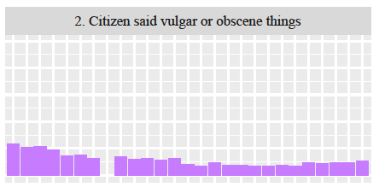

“Are there any situations you can imagine in which you would approve of a policeman striking an adult male citizen?”

Note: Total population for variable “POLHITOK” (N=29,164).

“Yes” responses (*n*=22,463; 77%).

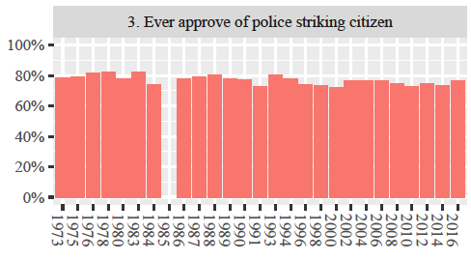

“Are there any situations you can imagine in which you would approve of a policeman striking an adult male citizen? [What if the adult male citizen] had said vulgar and obscene things to the policeman?”

Note: Total population for variable “POLABUSE” (N=29,721).

“Yes” response (*n*=3,507; 11.8%).

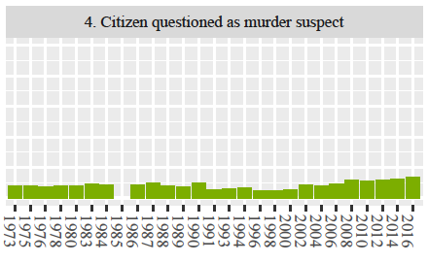

“Are there any situations you can imagine in which you would approve of a policeman striking an adult male citizen? [What if the adult male citizen] was being questioned as a suspect in a murder case?”

Note: Total population for variable “POLMURDR” (N=29,653).

“Yes” response (*n*=2,501; 8.4%).

# Figure 5A, B, C, D. White Attitudes on Race and Welfare (1973-2016)

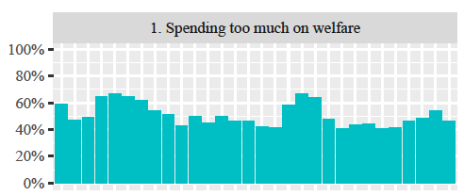

“We are faced with many problems in this country, none of which can be solved easily or inexpensively. I'm going to name some of these problems, and for each one I'd like you to name some of these problems, and for each one I'd like you to tell me whether you think we're spending too much money on it, too little money, or about the right amount. First, are we spending too much, too little, or about the right amount on welfare?”

Note: Total population for variable “NATFARE” (N=28,182).

“Too much” responses (*n*=14,732; 52.3%).

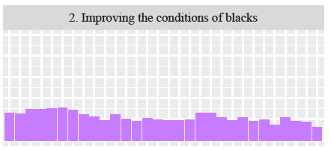

“We are faced with many problems in this country, none of which can be solved easily or inexpensively. I'm going to name some of these problems, and for each one I'd like you to name some of these problems, and for each one I'd like you to tell me whether you think we're spending too much money on it, too little money, or about the right amount. First, are we spending too much, too little, or about the right amount on improving the conditions of Blacks?”

Total population for variable “NATRACE” (N=26,649).

“Too much” responses (*n*=6,148; 23.1%).

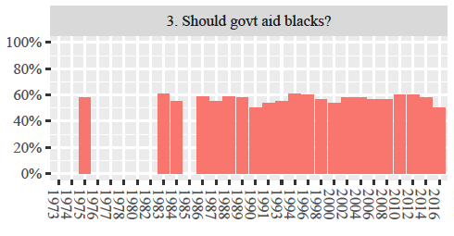

“Some people think that (Blacks/Negroes/African-Americans) have been discriminated against for so long that the government has a special obligation to help improve their living standards. Others believe that the government should not be giving special treatment to (Blacks/Negroes/African-Americans). Where would you place yourself on this scale, or haven't you made up your mind on this?”

Total population for variable “HELPBLK” (N=25,101).

“No special treatment” responses (n=8,772; 34.9%).

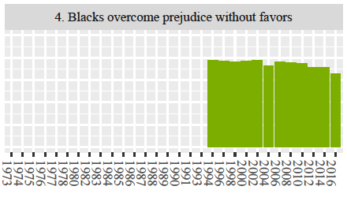

“Do you agree strongly, agree somewhat, neither agree nor disagree, disagree somewhat, or disagree strongly with the following statement: Irish, Italians, Jewish and many other minorities overcame prejudice and worked their way up. Blacks should do the same without special favors.”

Total population for variable “WRKWAYUP” (N=14,123).

“Agree Strongly” and “Agree Somewhat” responses (n=10,532; 74.6%).

# **TABLES**